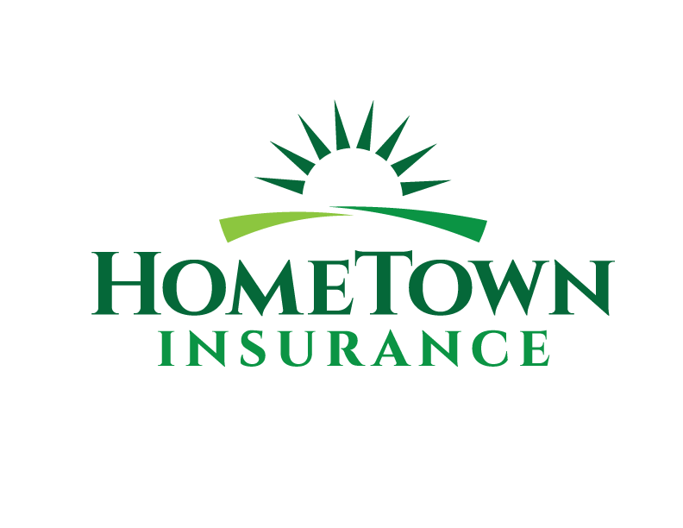
Privacy Policy
Effective Date: March 2025
HomeTown Insurance (“we,” “our,” “us”) respects your privacy and is committed to protecting the personal information you provide while using our website myHT.biz (the “Website”). This Privacy Policy explains how we collect, use, and share your information. This policy also applies to our subsidiaries, HomeTown Solutions and HomeTown Captive.
Information We Collect
When you interact with our Website, we may collect the following personal information:
- Name
- Phone number
- Email address
- Any other information you voluntarily submit through our forms
Additionally, we use Google Analytics, which automatically collects data about your visit, including:
- Your device type, browser, and operating system
- Your IP address
- Pages you visit on our Website
- How you arrived at our Website (e.g. search engines, social media, direct visit)
- The path you take while navigating our Website
How We Use Your Information
We use the information collected for the following purposes:
- To contact you in response to inquiries or service requests
- To analyze Website traffic and improve user experience through Google Analytics
- To monitor how users interact with our Website and optimize our content accordingly
Sharing of Information
We do not sell or rent your personal information. We may share your information only:
- With third parties, such as insurance providers, only with your consent to process insurance quotes.
- As required by law, such as to comply with a legal request or protect our rights.
- With our email marketing service provider, for marketing communications.
Cookies & Tracking Technologies
We use cookies and similar tracking technologies to enhance your experience on our Website. Google Analytics collects anonymous data to help us understand visitor interactions and improve our Website. You can control or disable cookies through your browser settings.
Data Security Measures
We take reasonable security measures to protect your personal information from unauthorized access, alteration, or disclosure. While no online service is completely secure, we implement safeguards such as:
- Encryption of sensitive data
- Secure servers and restricted access to personal information
- Regular security audits and updates to maintain data protection
Information Retention
We retain personal information for as long as necessary to fulfill the purposes outlined in this Privacy Policy or as required by law. If you wish to request deletion of your personal data, please contact us at info@myHT.biz.
User Rights & Choices
You have the right to:
- Request information about the data we collect about you.
- Request correction of deletion of your personal data.
- Opt-out of Google Analytics tracking as mentioned above.
- Opt-out of marketing communications by emailing us at info@myHT.biz.
To make a request regarding your data, please contact us at info@myHT.biz.
Legal Compliance
We comply with applicable state and federal privacy laws to ensure the protection of your personal information. This includes adhering to regulations governing data collection, usage, and retention.
Contact Information
If you have any questions about this Privacy Policy or your data privacy rights, please contact us at:
HomeTown Insurance
Email: info@myHT.biz
We reserve the right to update this Privacy Policy as needed. Any changes will be posted on this page with an updated effective date.

